Chapter 9, Solution 86.

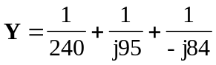

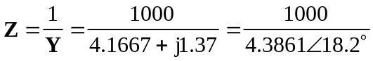

Z = 228-18.2 

